Flynn’s Taxonomy
In 1966, computer scientist Dr. Michael J. Flynn proposed a classification of computer architectures based on their capability to process the number of instruction streams and data streams concurrently. This classification is still relevant and known as Flynn’s taxonomy.
In his initial paper, Flynn proposed four classifications:
Single instruction stream, single data stream (SISD)
Single instruction stream, multiple data streams (SIMD)
Multiple instruction streams, single data stream (MISD)
Multiple instruction streams, multiple data streams (MIMD)

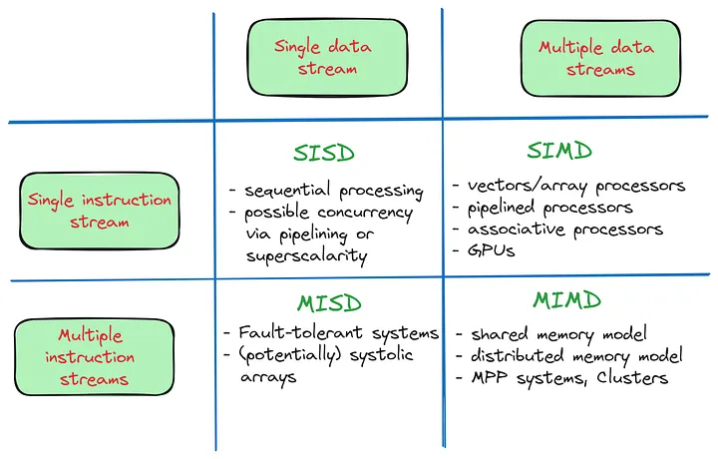
Flynn published three further classifications of SIMD in a subsequent paper published in 1972: Array Processors, Pipelined processors, and Associative Processors.
“Stream” refers to the sequence of data or instructions as seen by the machine during the execution of a program.
A single stream issues one element in each time unit, resembling a queue. Conversely, multiple streams typically issue numerous elements per time unit, akin to managing multiple queues simultaneously.

